**Assignment 2**

**Made by: Vivek Devram Thakur**

**1). Products**

**1.1). Products Table:**

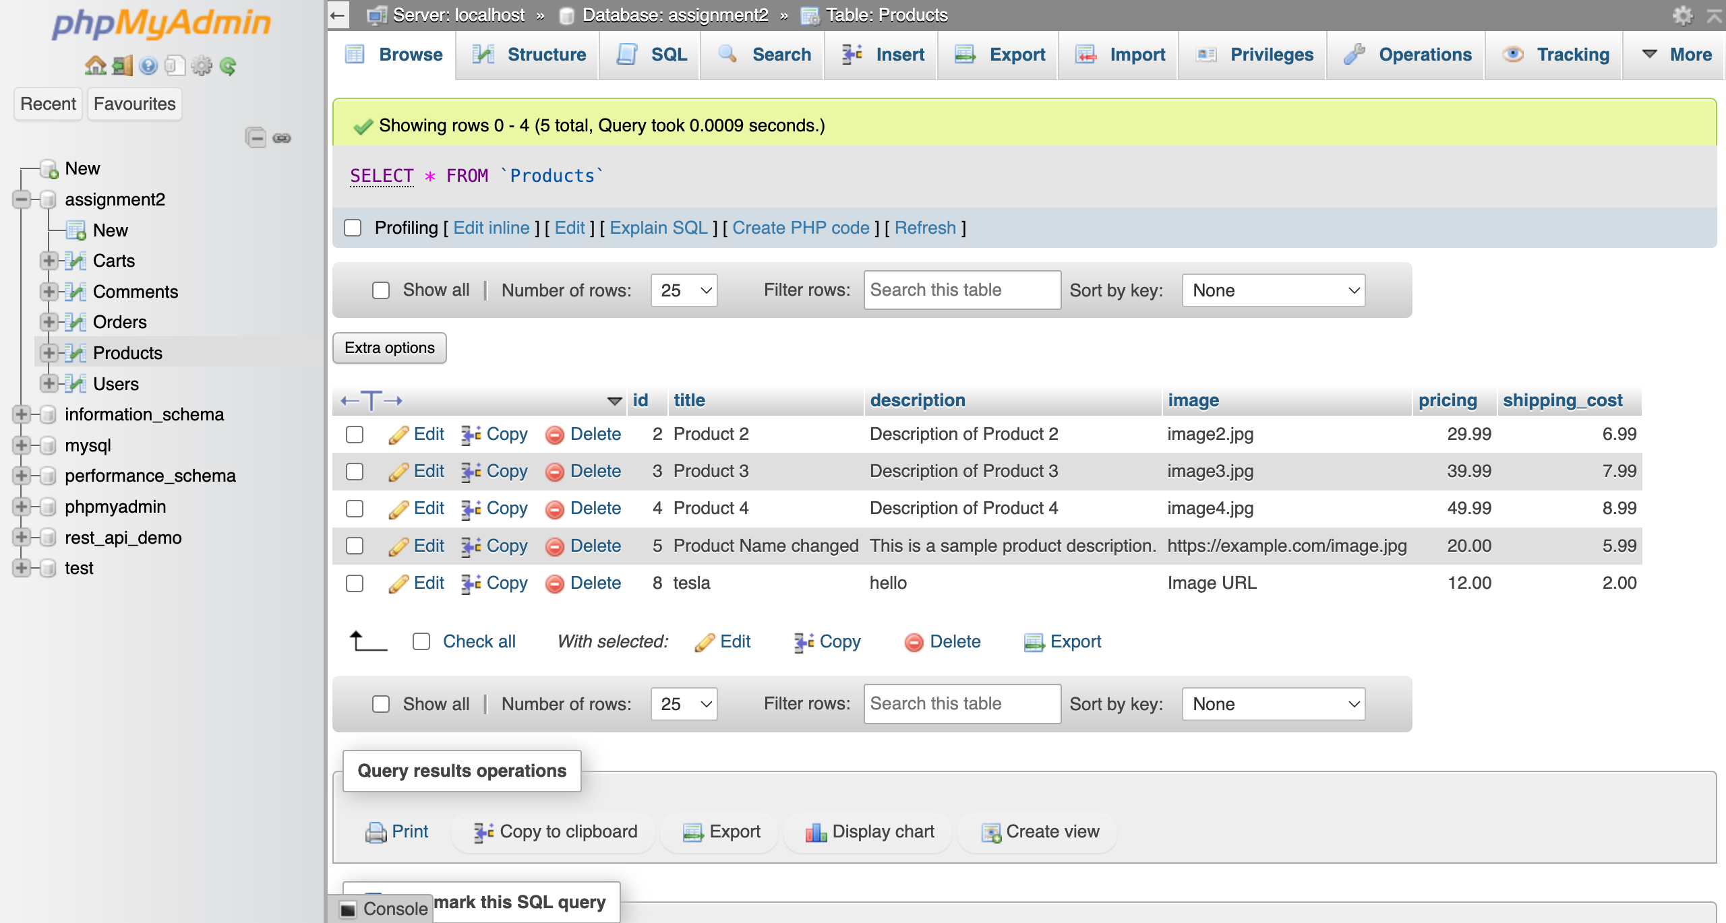

**1.2). Products Create API (http POST Request):**

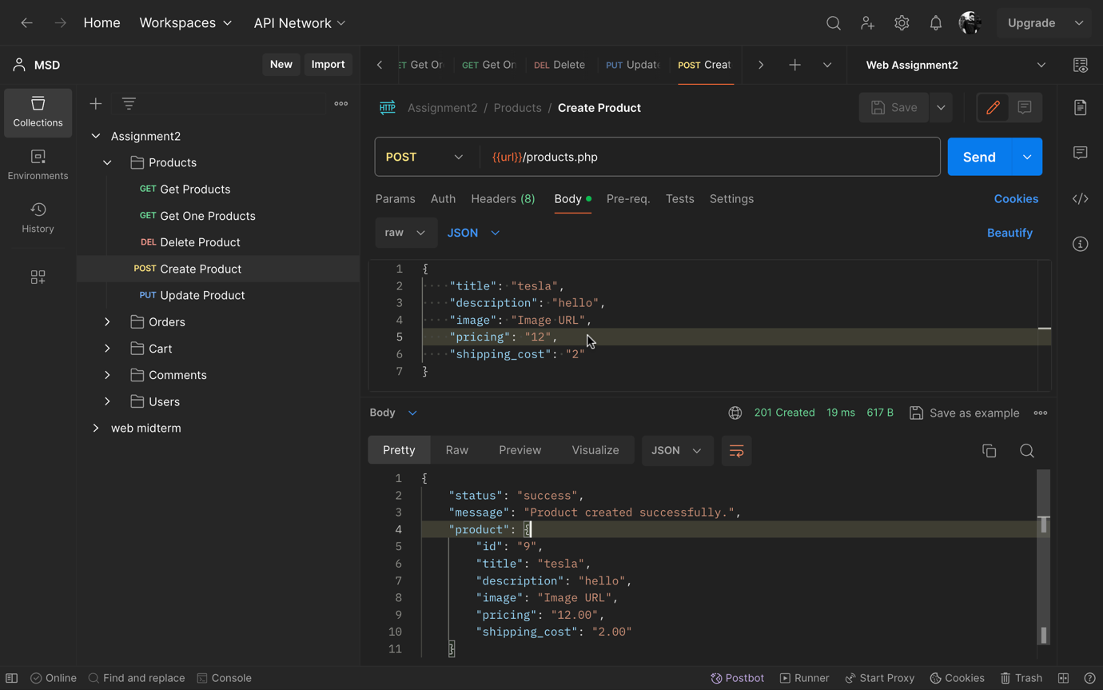

**1.3). Products Update API (http PUT Request):**

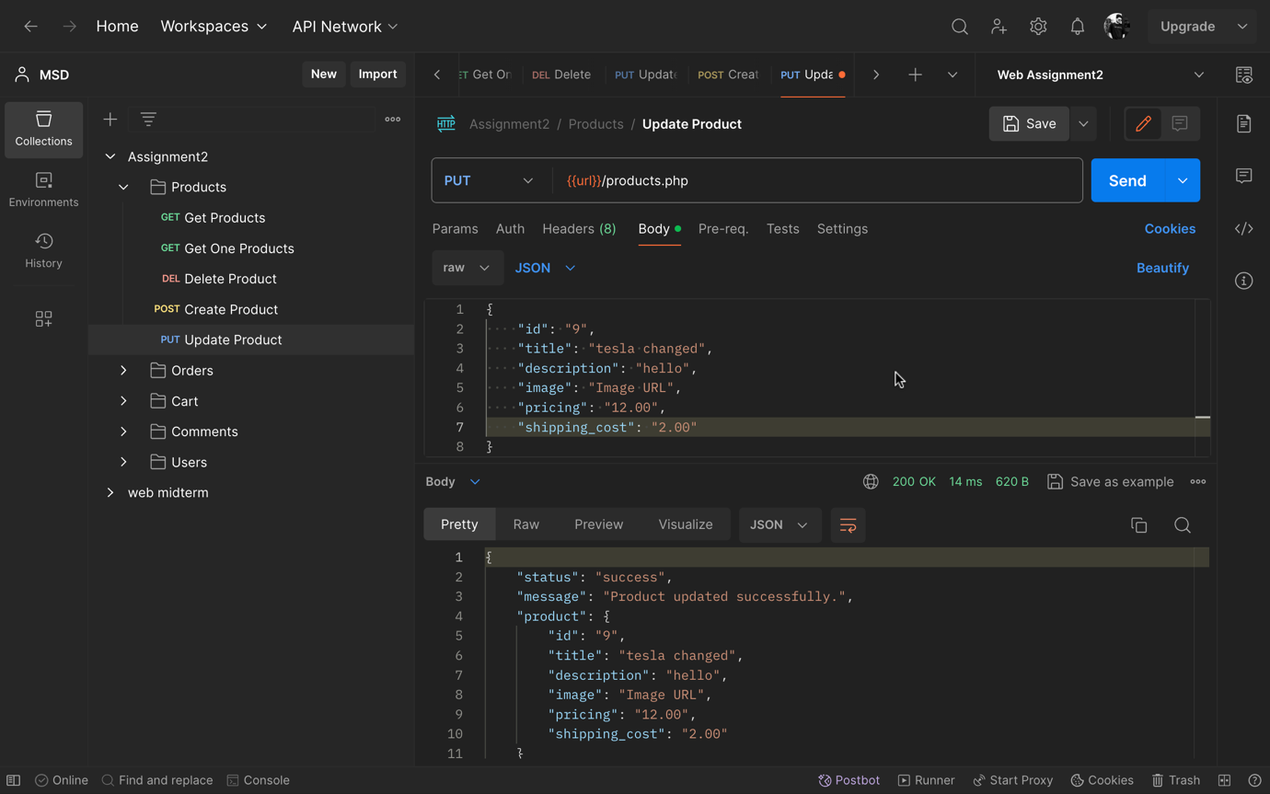

**1.4). Products Get All API (http GET Request):**

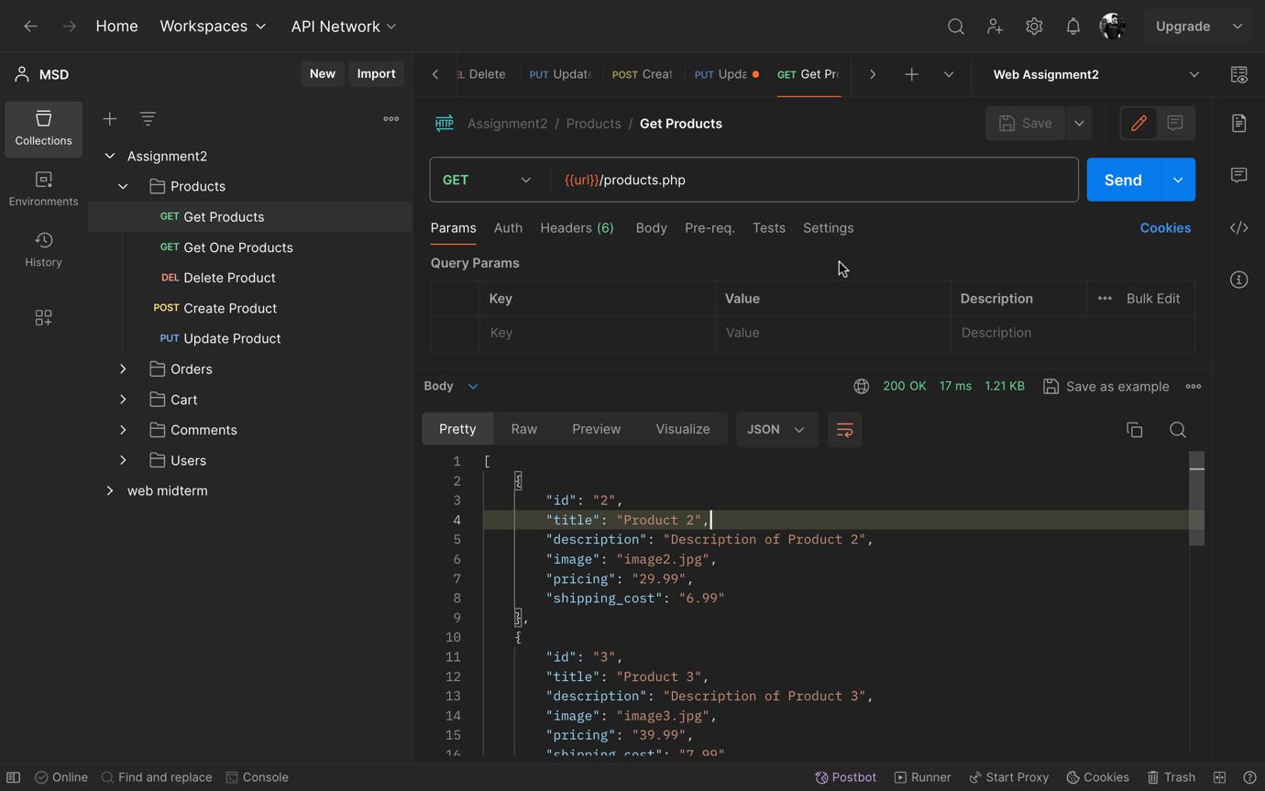

**1.5). Products Get One by ID API (http GET Request):**

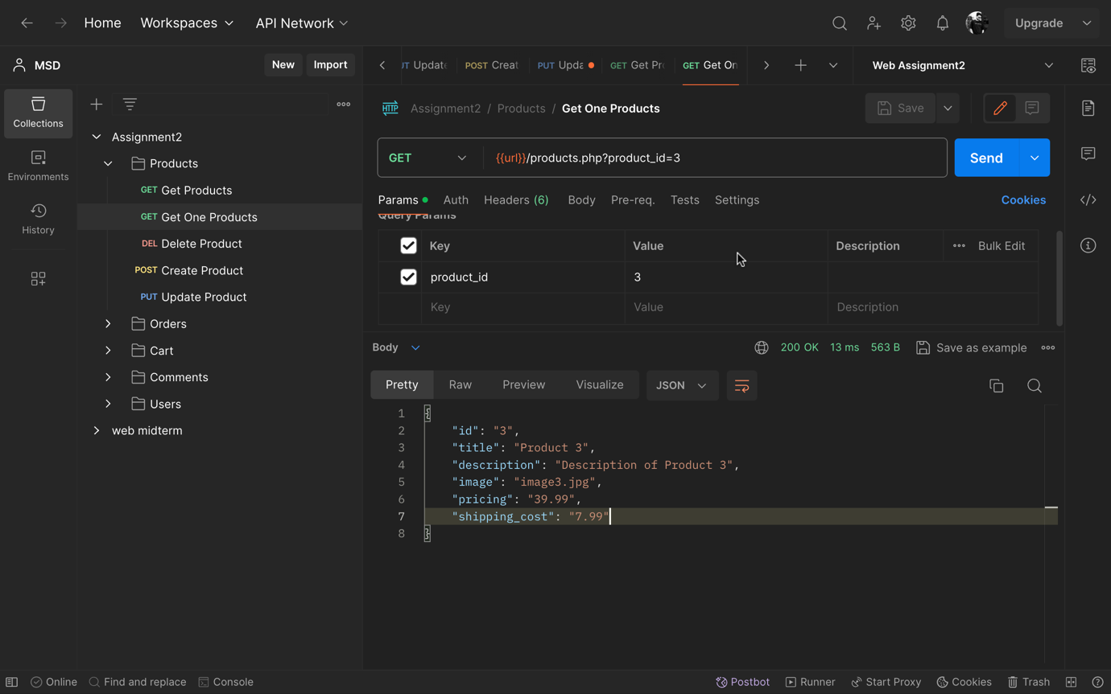

**1.6). Products Get One by ID API (http GET Request):**

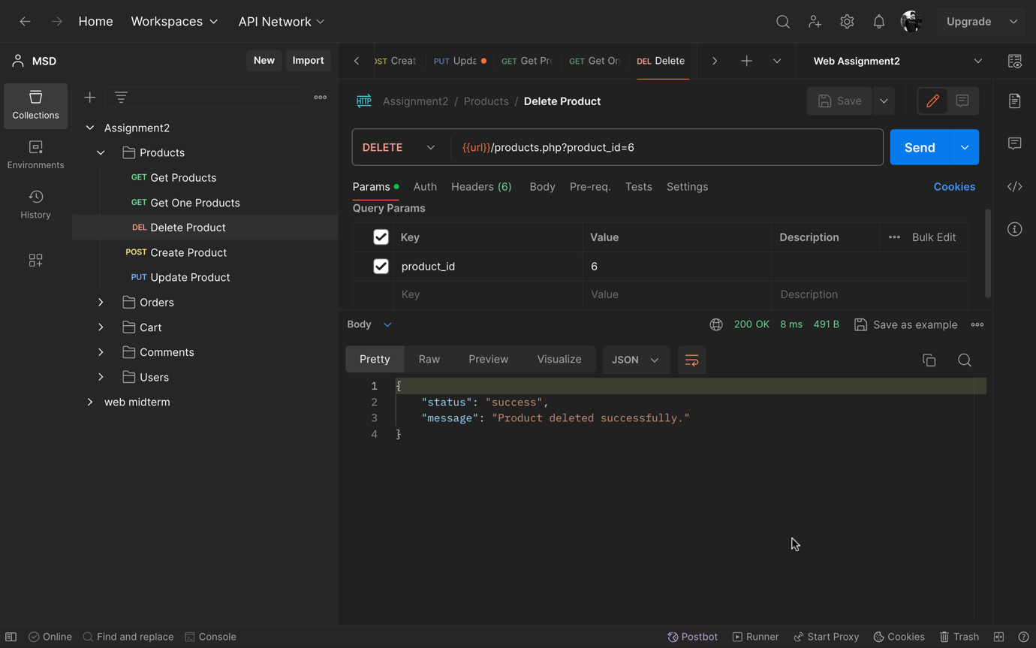

**2). Users**

**2.1). Users Table:**

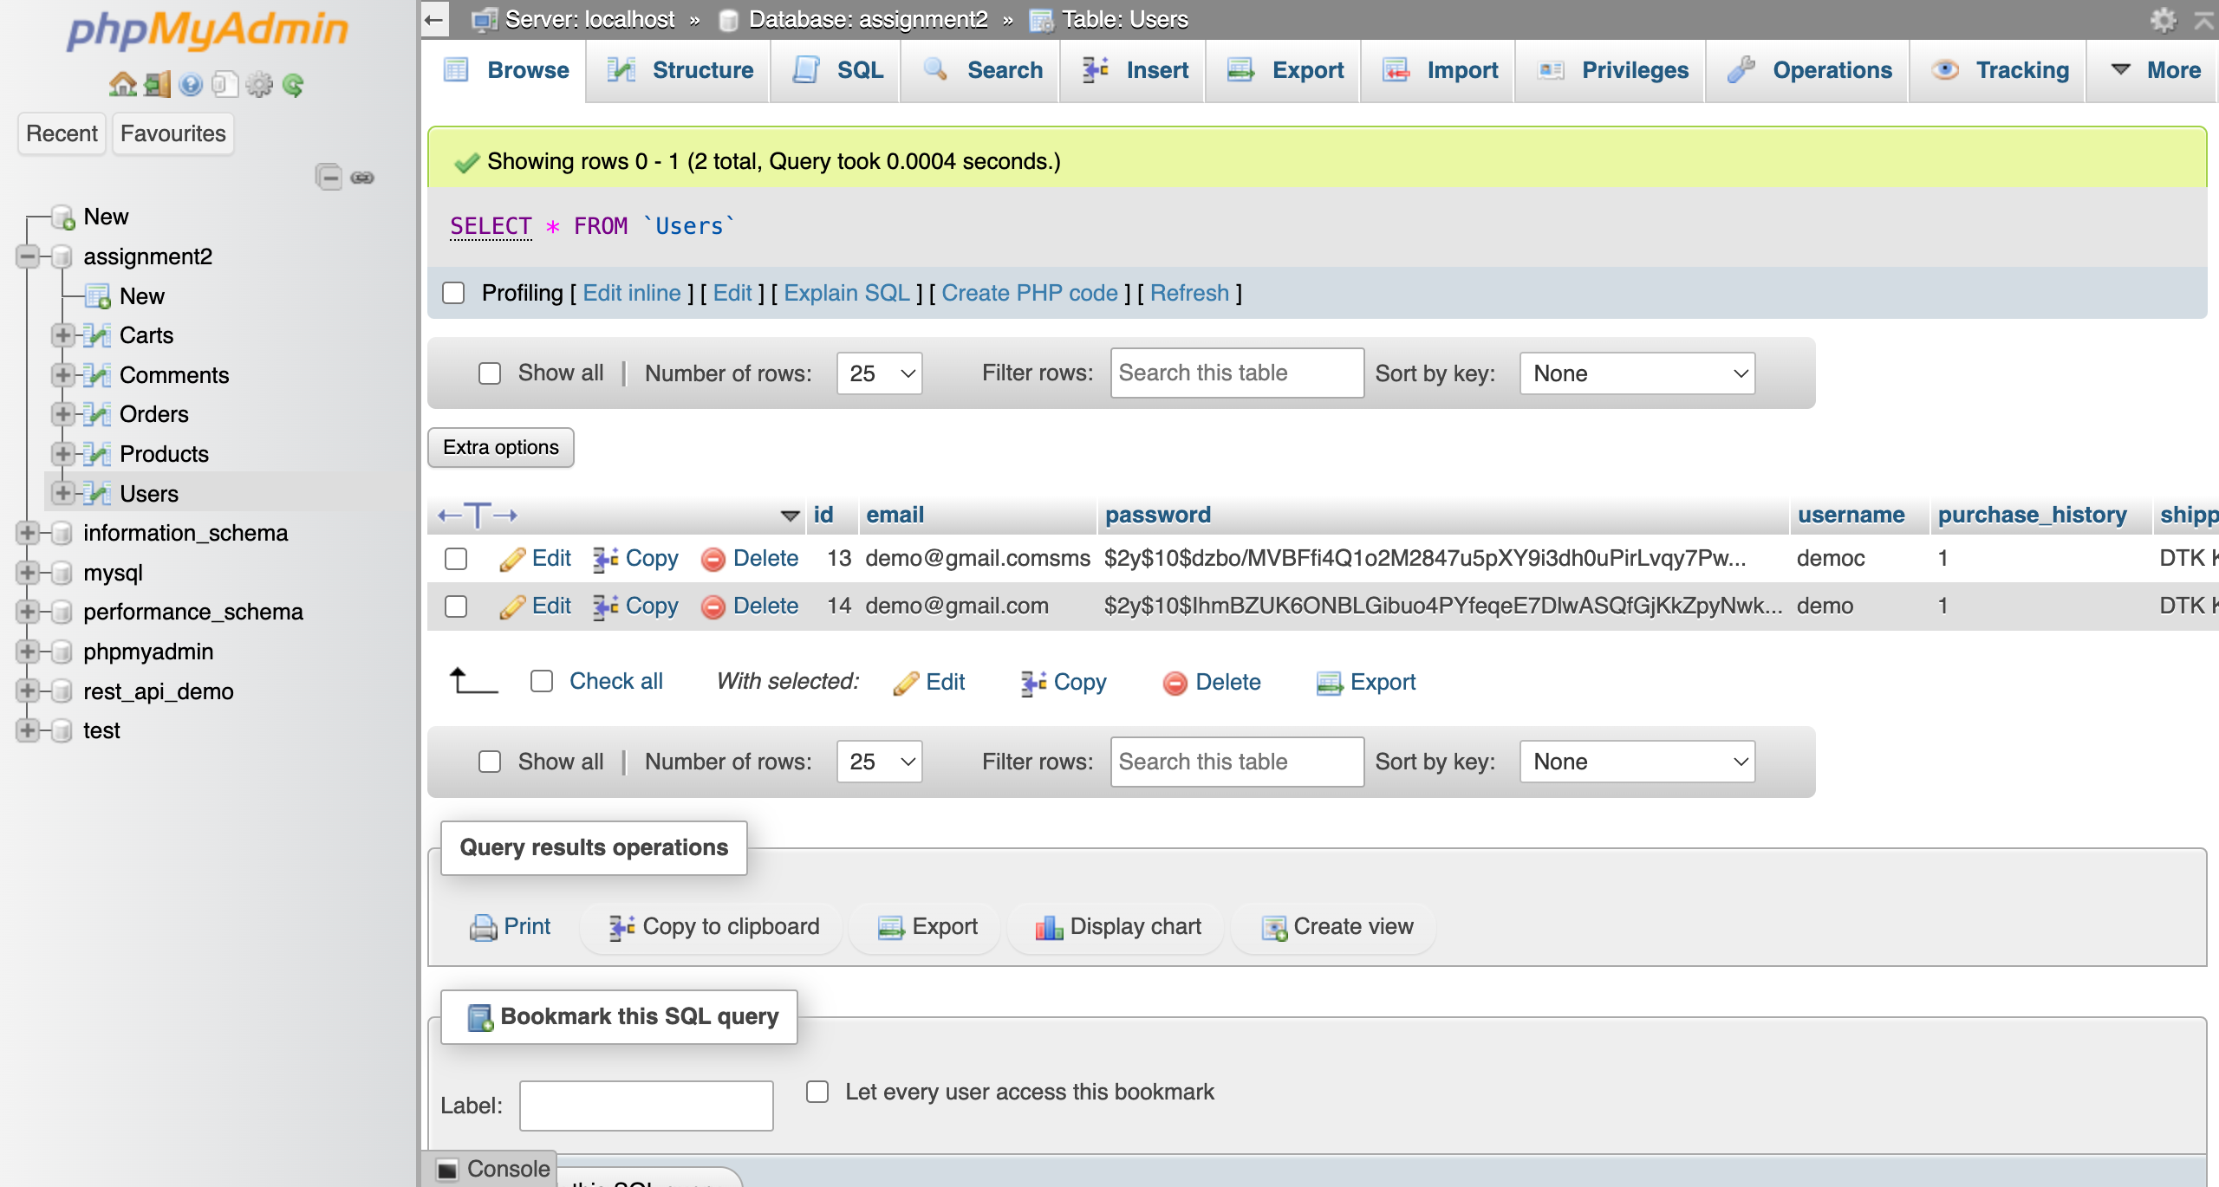

**2.2). Users Register API (http POST Request):**

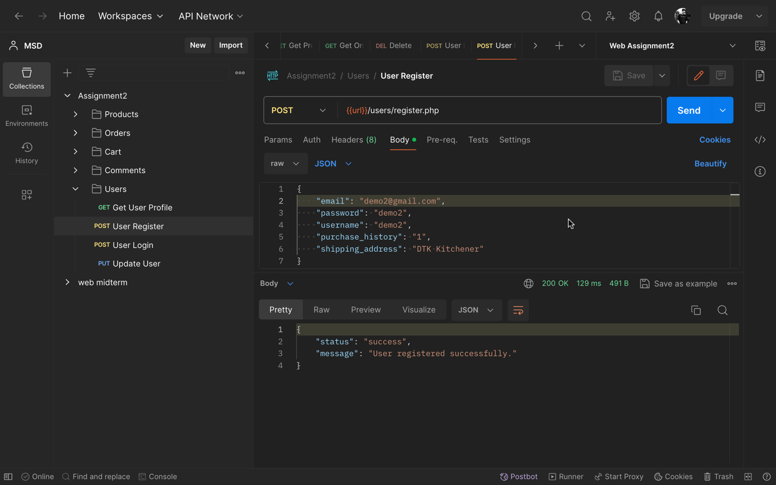

**2.3). Users Login API (http POST Request):**

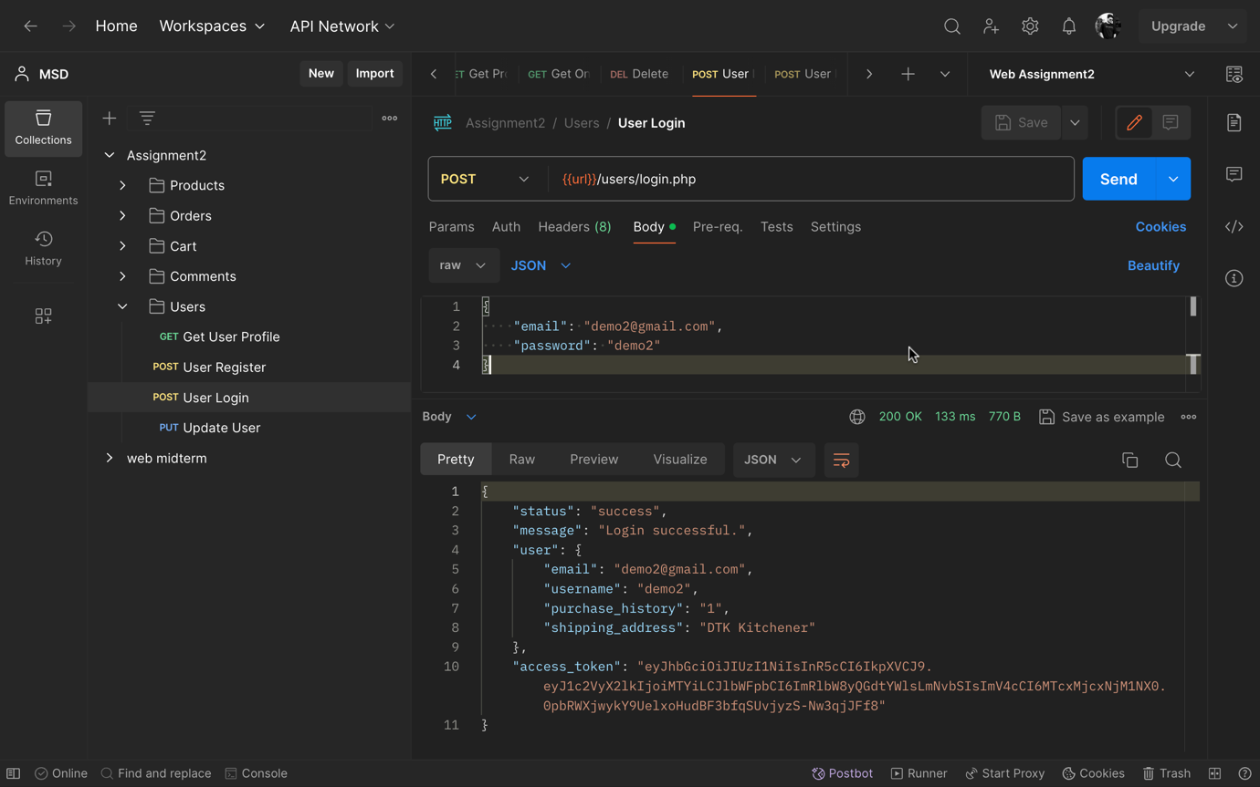

**2.4). Users Update API (http PUT Request):**

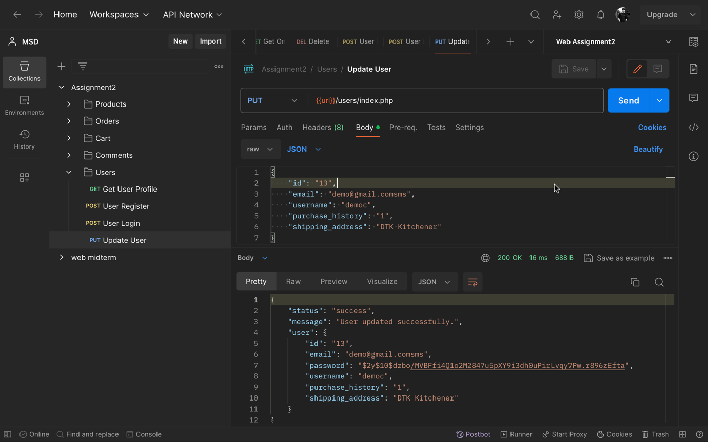

**2.5). Users Get API (http GET Request):**

By passing the jwt access token in request header.

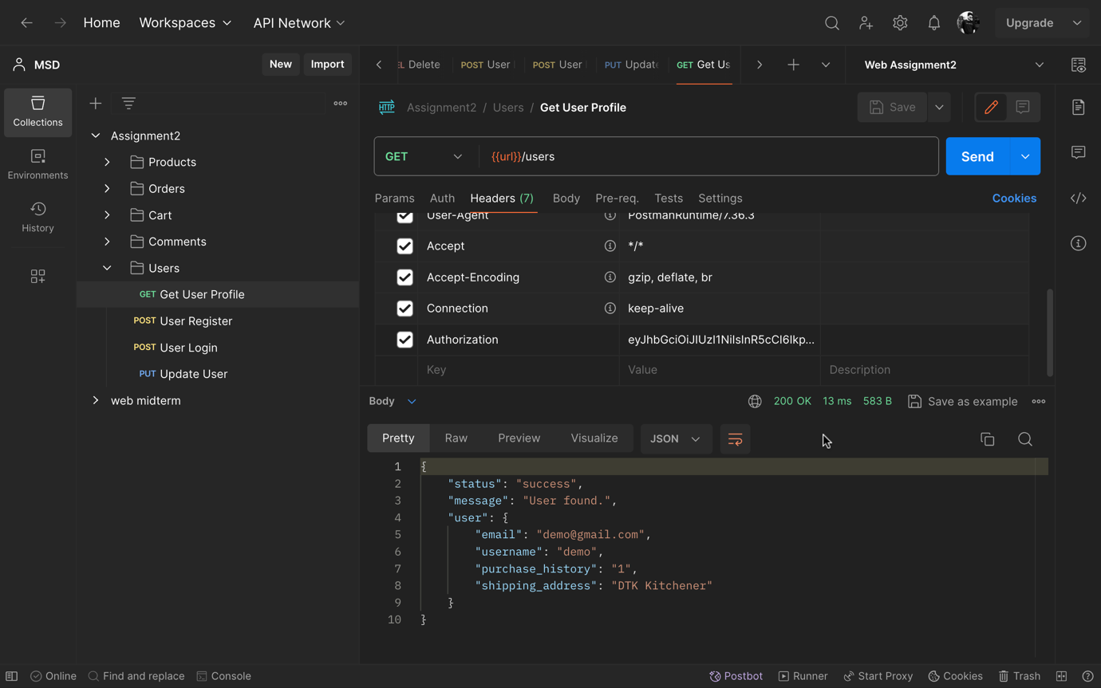

**3). Comments**

**3.1). Comments Table:**

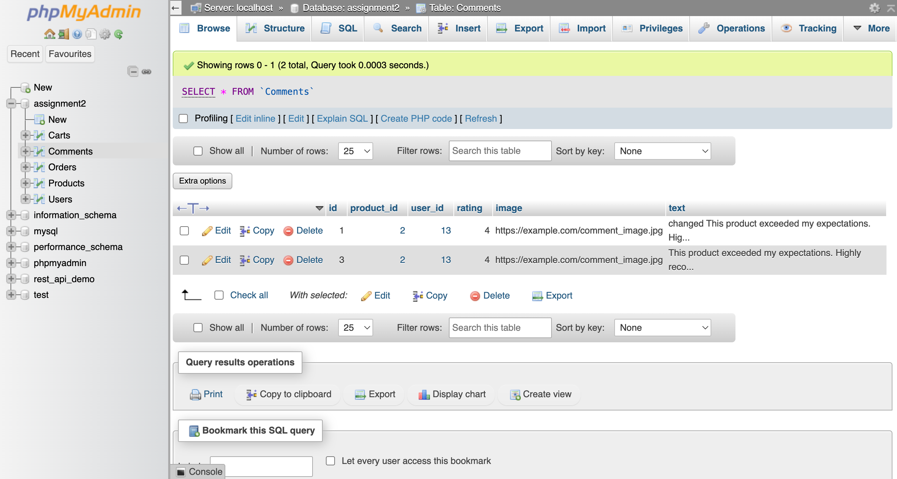

**3.2). Comments Create API (http POST Request):**

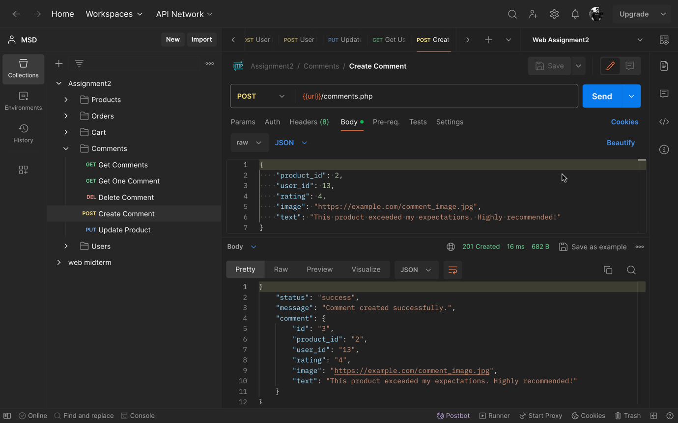

**3.3). Comments Update API (http PUT Request):**

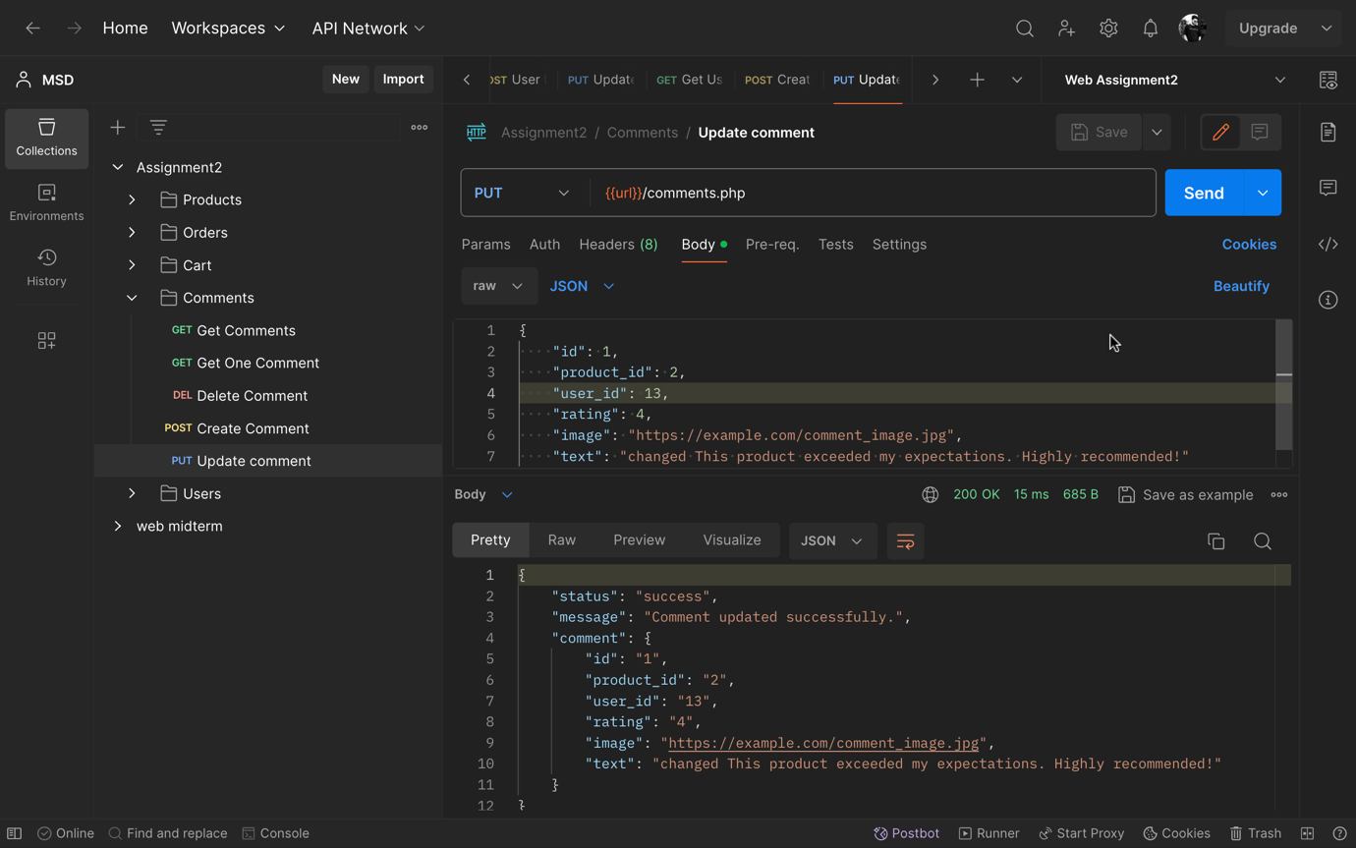

**3.4). Comments Get All API (http Get Request):**

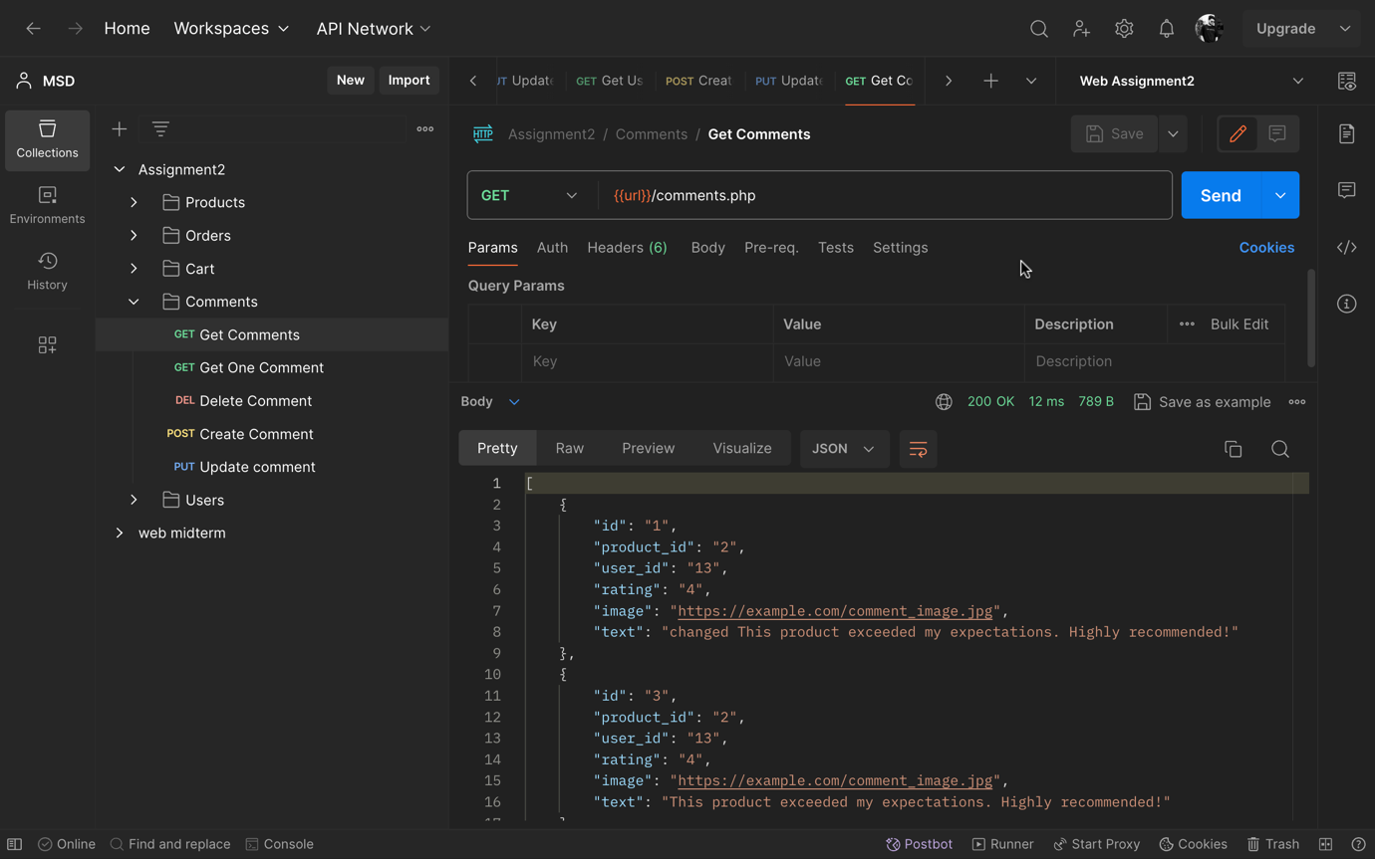

**3.5). Comments Get one by Id API (http Get Request):**

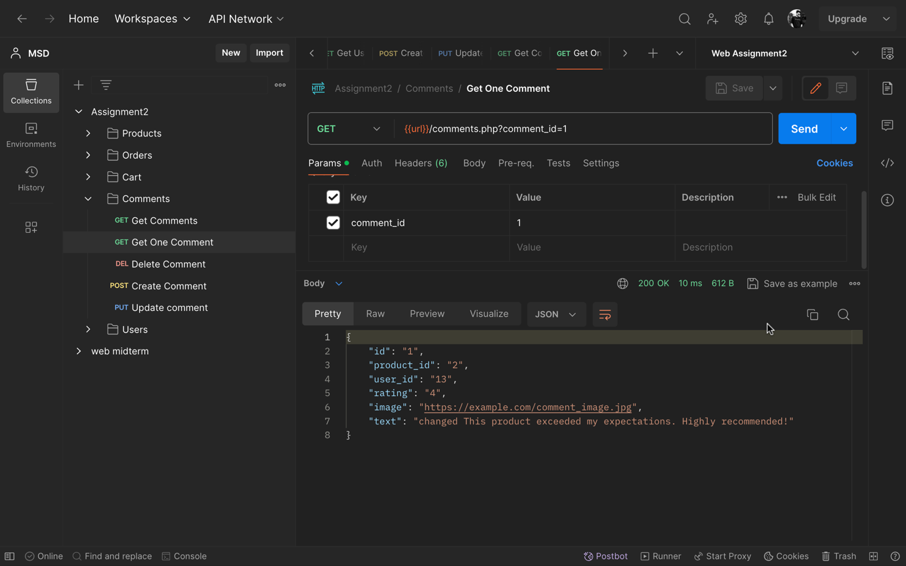

**3.6). Comments Delete API (http DELETE Request):**

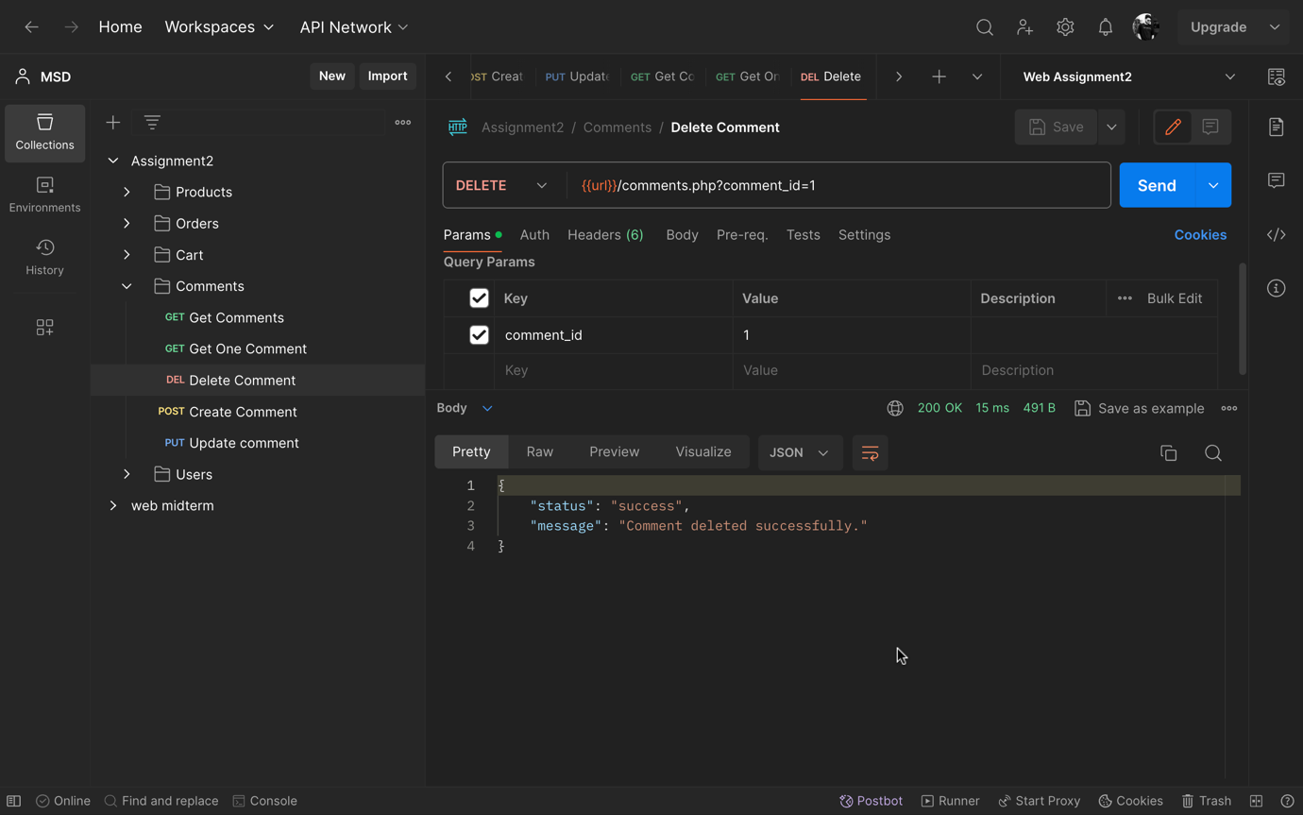

**4). Cart**

**4.1). Cart Table:**

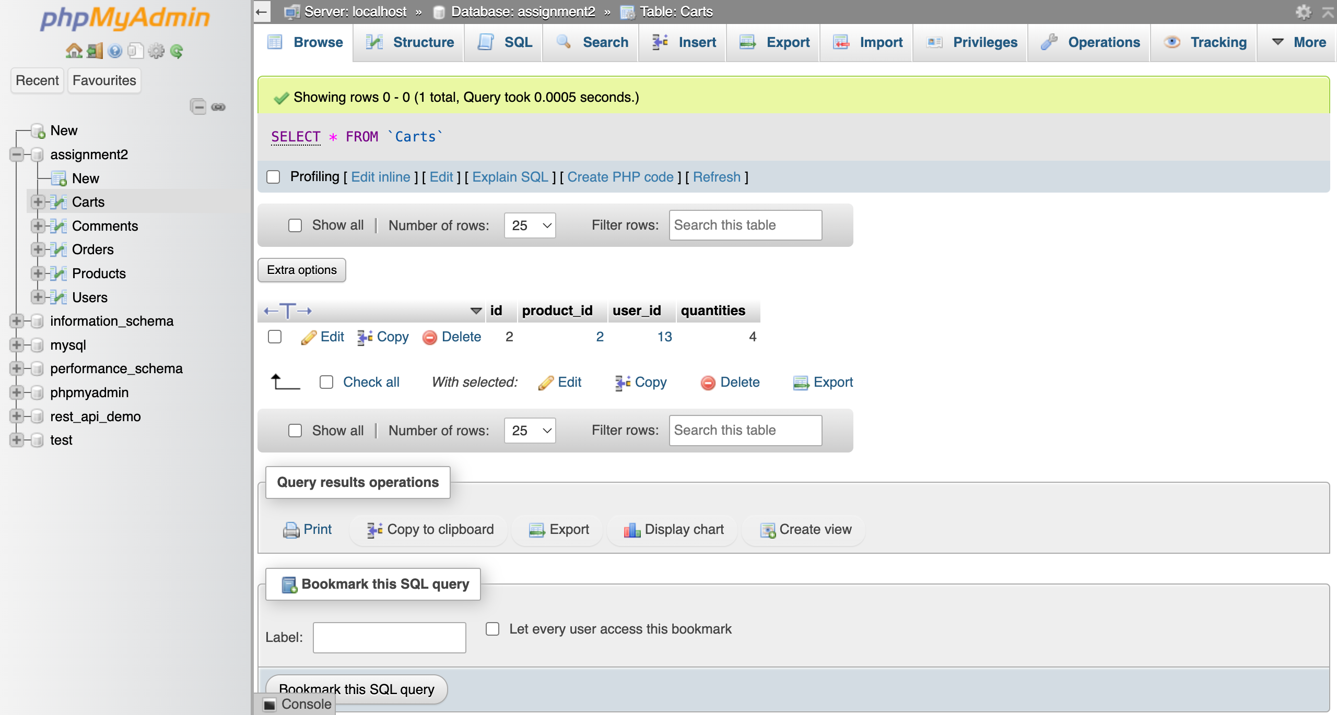

**4.2). Cart Create API (http POST Request):**

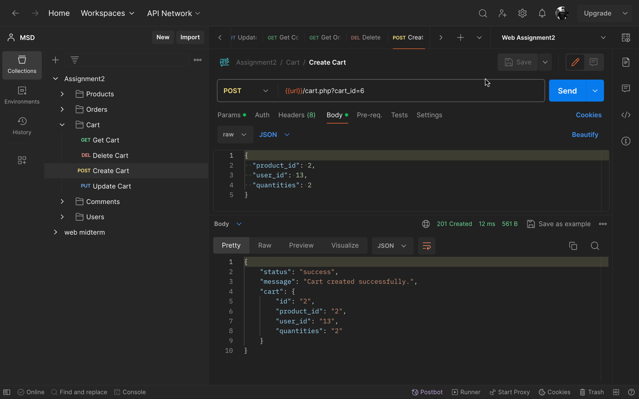

**4.3). Cart Update API (http PUT Request):**

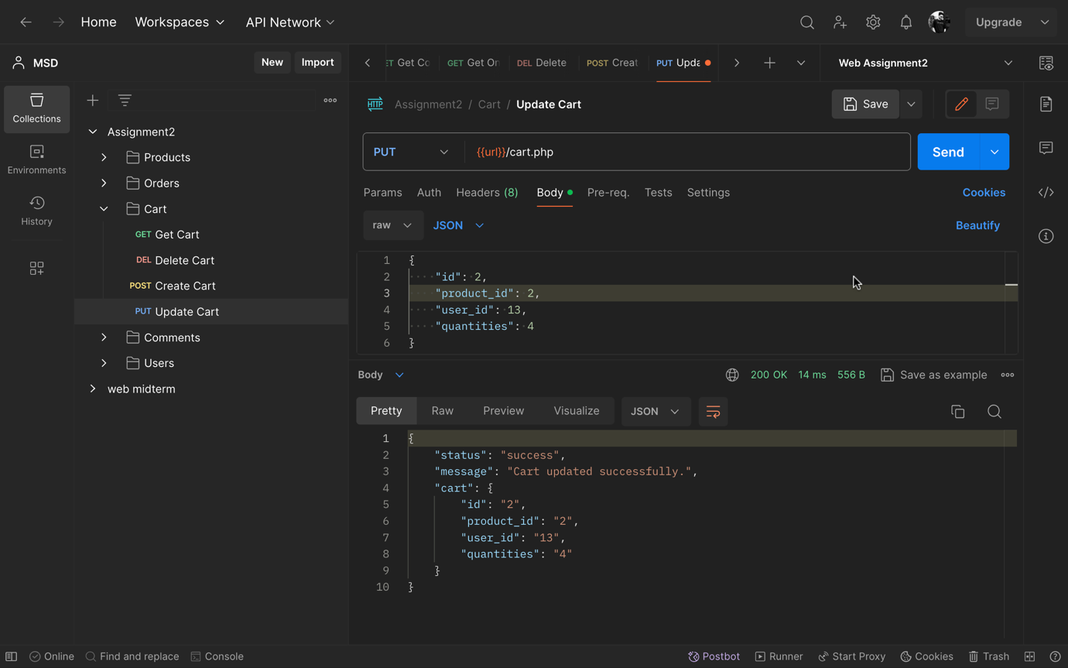

**4.4). Cart Get API (http GET Request):**

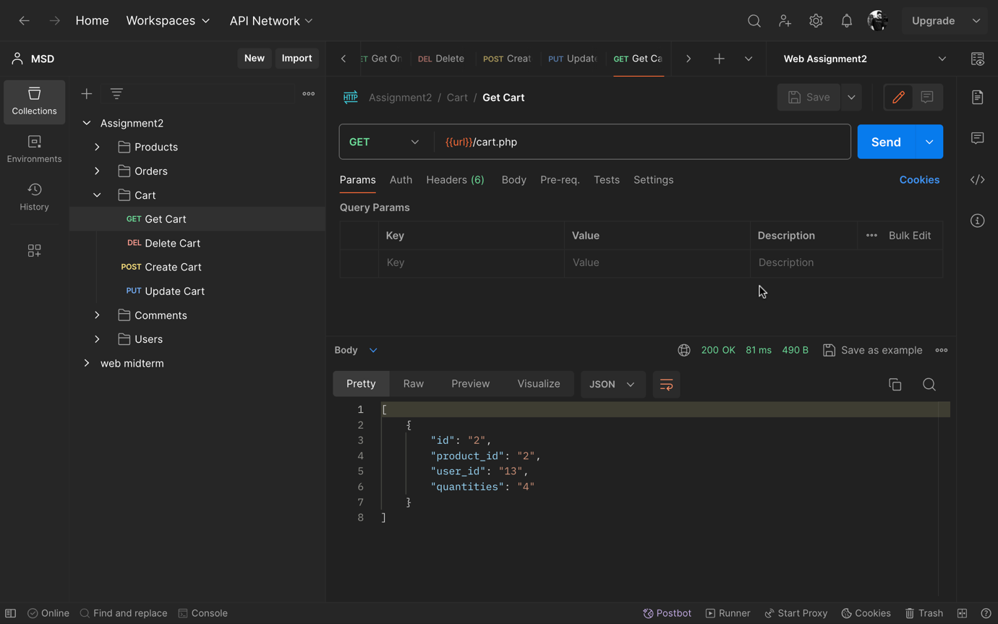

**4.5). Cart Delete API (http DELETE Request):**

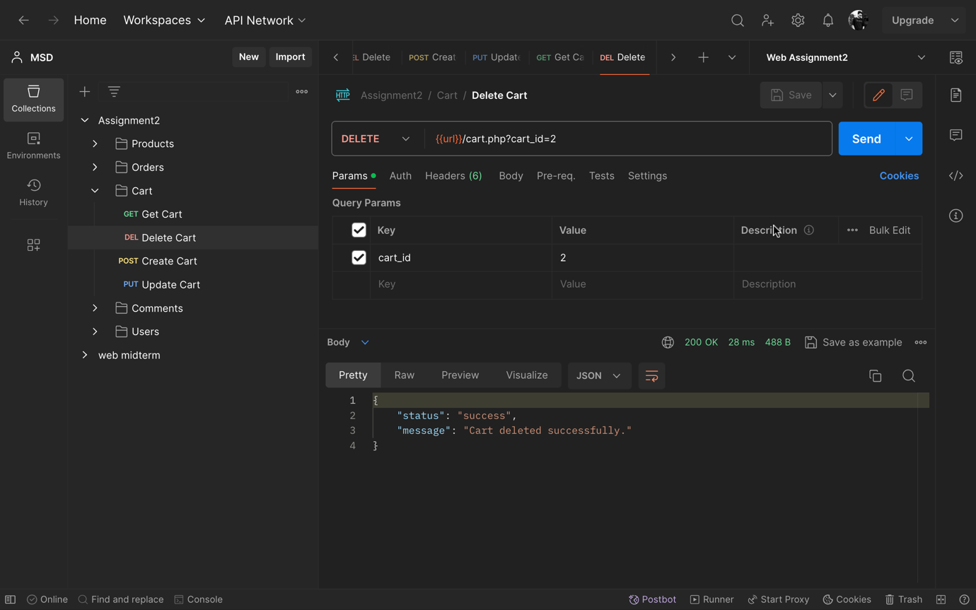

**5). Orders**

**5.1). Order Table:**

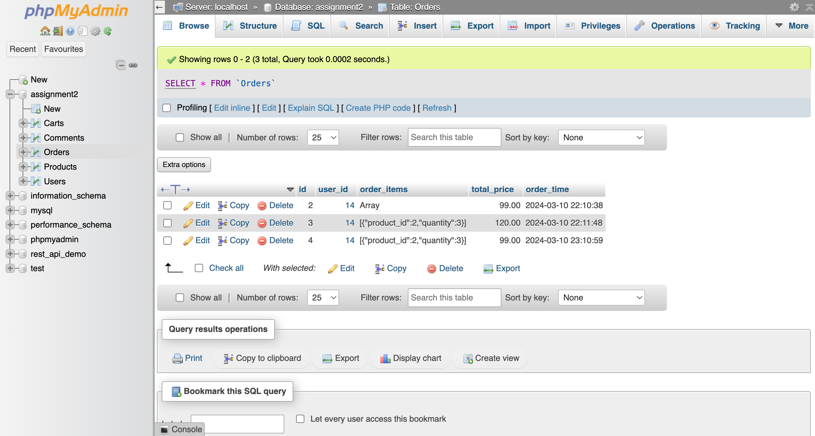

**5.2). Order Create API (http POST Request):**

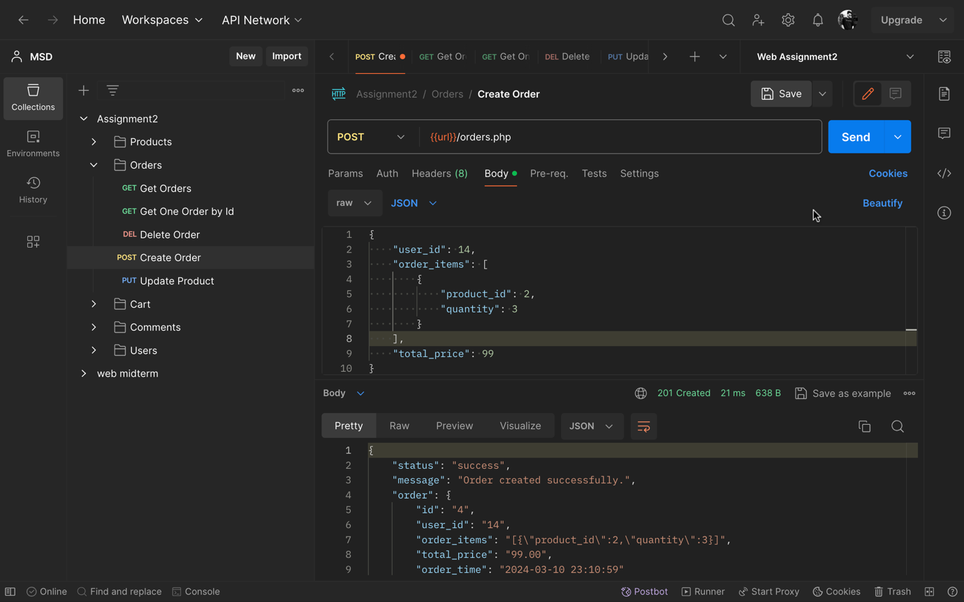

**5.3). Order Update API (http PUT Request):**

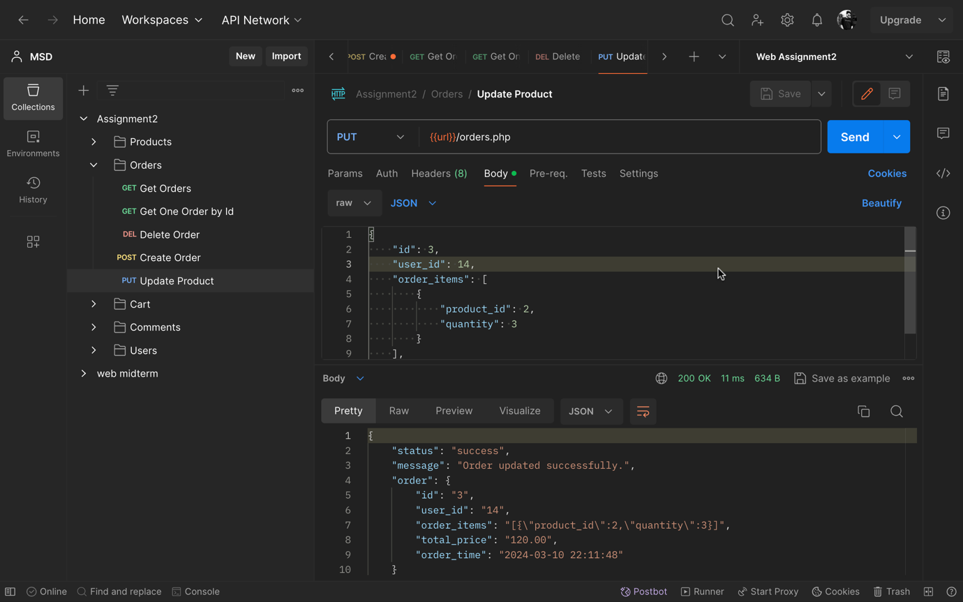

**5.4). Order Get All API (http GET Request):**

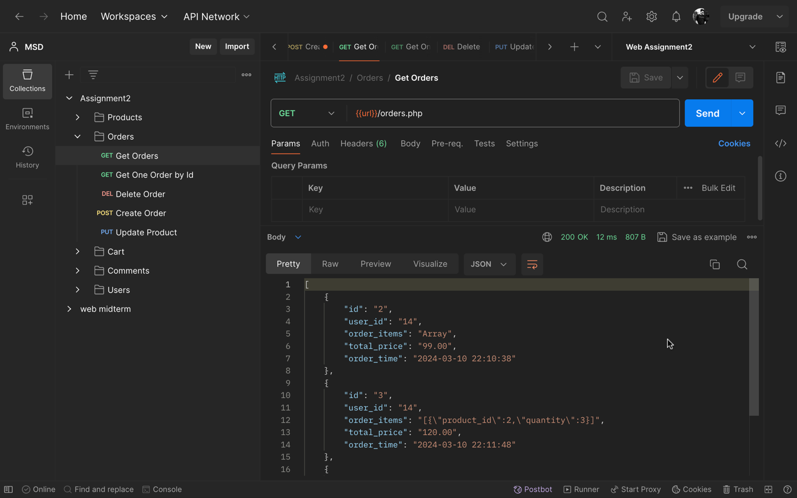

**5.5). Order Get One by Id API (http GET Request):**

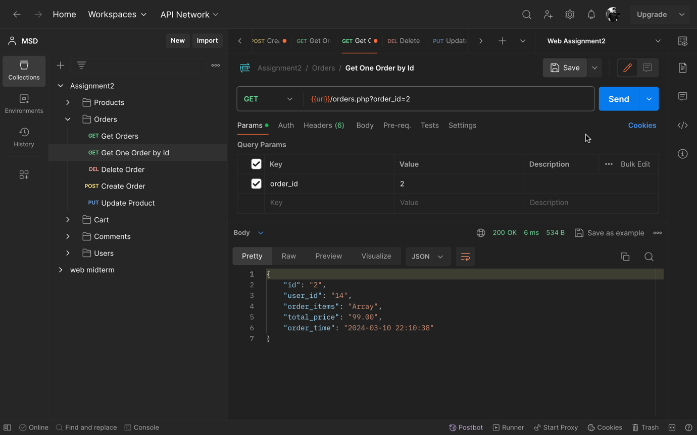

**5.6). Order Delete API (http DELETE Request):**

